“Dirt Rich” Community Composting Program

Drop Off Location:
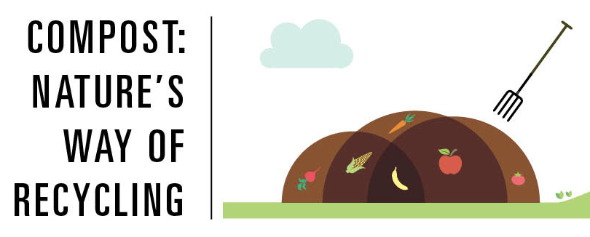
(YOUR ADDRESS / LOCATION HERE)

Community composters are individuals, businesses, and families who share a passion for making and using compost to minimize waste and reduce our carbon footprint.

Projects or groups range in scale from individuals working within schools or families promoting home composting, to community supported agriculture schemes, to social enterprises with Local Authority contracts providing curbside collection services, with lots more variety in-between.

We can be leaders in the community by managing the organic waste we produce instead of filling landfills with a renewable resource: rich dirt!

Community Composting has many environmental and social benefits:
- Reduction of waste going to landfill or incineration
- Training, possible employment, educational and volunteering opportunities
- Improve soil health and conservation and carbon sequestration
- Utilizing the proximity principle to convert 'waste' problem into a locally available resource

Getting Started:
Keep a separate trash can, bucket, or suitable container for food scraps. (If you use a brown paper bag, you can toss the whole bag into the compost drop-off container).

Yes:  Fruit and vegetable scraps  Pasta, bread, cereal  Coffee grounds, filters, & tea bags  Paper towels and paper towel rolls  Muffin wrappers  Dairy products  Meat (bones & trimmings)  Plant material (grass, leaves, weeds)  Wood chips  Paper plates, bags  Egg shells  Household plants  Shellfish, fish products  *Please add provided sawdust / shavings on top to control bugs / odor. Thank you! | No:  Plastic of any kind  Styrofoam  Metal of any kind, including foil  Candles  Corks  Gum  Cigarette butts  Baby wipes, diapers  Pet waste  Dryer lint sheets  Vacuum cleaner bags  Hair, pet fur  Dead animals  Fireplace or BBQ ashes  Glass  Pet food

